No.2 Chao Yang Men Bei Da Jie

Beijing 100027, P.R. China

Tel: (86 10) 6553 2288

Fax: (86 10) 6501 2501

Forest.zhao[@swissotel.com](mailto:Beijing@swissotel.com)

[reservations.beijing@swissotel.com](mailto:reservations.beijing@swissotel.com)

#### **Hotel Reservation Form**

***Group Name*:**

***Group Code:***

*Please reserve a room for the following guest(s)*

|  |  |  |  |
| --- | --- | --- | --- |
| *Guest name:*  *Mr / Mrs: ……………….. Surname: ……………………...* *First Name:* | | | |
| Confirmation no:       **[to be filled by Swissotel Beijing]** | | | |
| Arrival date: | Arrival flight details: | | |
| Departure date: | Departure flight details: | | |
| E Email: | | | |
| No of rooms:       No of pax:  **Classic Single Room: (CNY750.00, with 1 daily breakfast)**  **Double/twin Room: (CNY850.00, with 2 daily breakfast)** | | | |
| * **Rate includes 10% service charge and 6% applicable taxes, WIFI, exclusive daily buffet breakfast** | | |  |
| ***Rooms are subjected to availability upon confirmation.*** | | | |
| **Billing:** Please guarantee your reservation by credit card:    AMEX |  Visa |  Diners Club |  MasterCard | | | |
| Card number: | | Expiry date: | |
| Name of Card Holder: | | Signature: | |

**We reserve the rights to cancel any booking without credit card guarantee.**

**Within 24 hours and no show, a total full night reserved will be applied for any cancelation from the total room block.**

The check in time is 14.00 on the day of arrival. Check out time is at 12.00.

Early occupancy of rooms before 14:00 hrs is subject to availability.

On the day of departure, rooms held until 18.00 hrs are charged 50% of the above contracted rates and are subject to availability. All rooms held after 18.00hrs will be charged a full night’s rate.

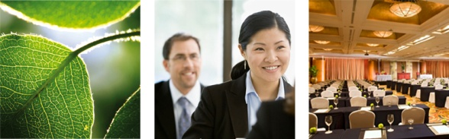

**Reservations Department**

Tel: (86 10) 6553 2288 ext. 2142 / 2122 / 2207

Fax (86 10) 6501 2506

Email: reservations.beijing@swissotel.com

**Sales Department**

Forest Zhao

Tel: (86 10) 6553 2288 ext. 2250

Fax: (86 10) 6501 3821

Email: forest.zhao@swissotel.com

**Note: All reservations request must be sent to the hotel before March. 31, 2018.**

**After the cut-off date, rooms and room rates would be subject to availability.**

**AIRPORT TRANSFER SERVICE**

Hotel provides airport transportation service. The airport pick up service cost 588 CNY per trip for AUDI A6 that can seat 2 people.

If you would like to arrange it, Please let me know the date, flight number, arrival time, number of people.

Please do not hesitate to contact us if we can be of further assistance, in the meantime we look forward to welcoming you at Swissotel Beijing.

Forest Zhao

Sales Manager